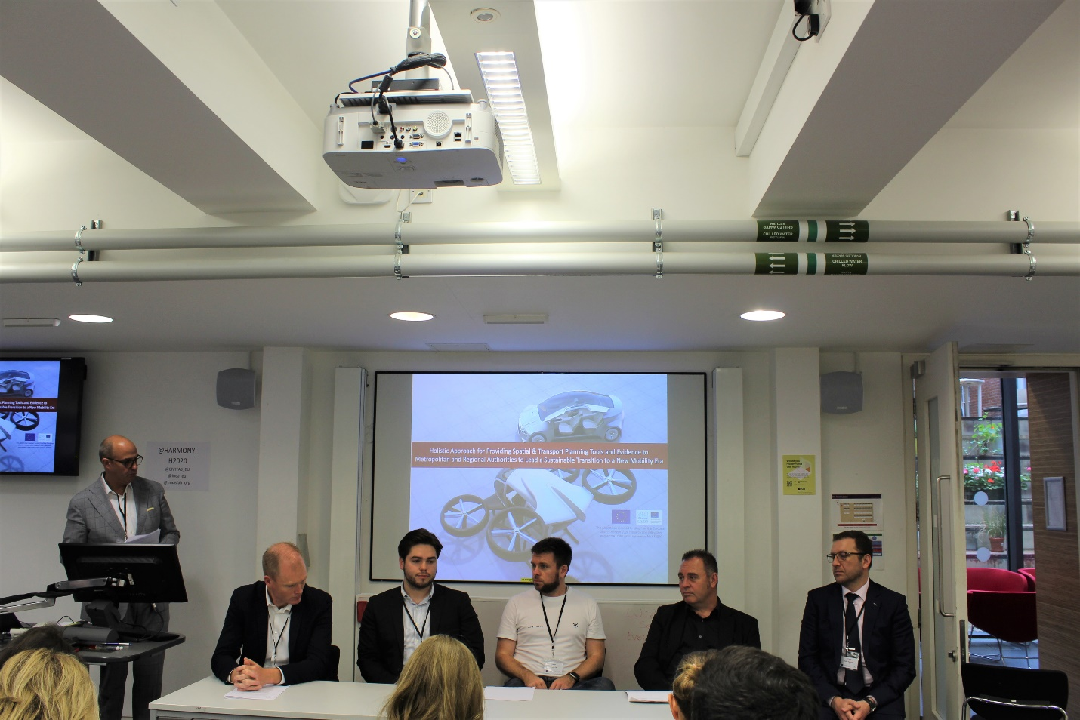

First panel at the HARMONY launch event, London, 7th June 2019
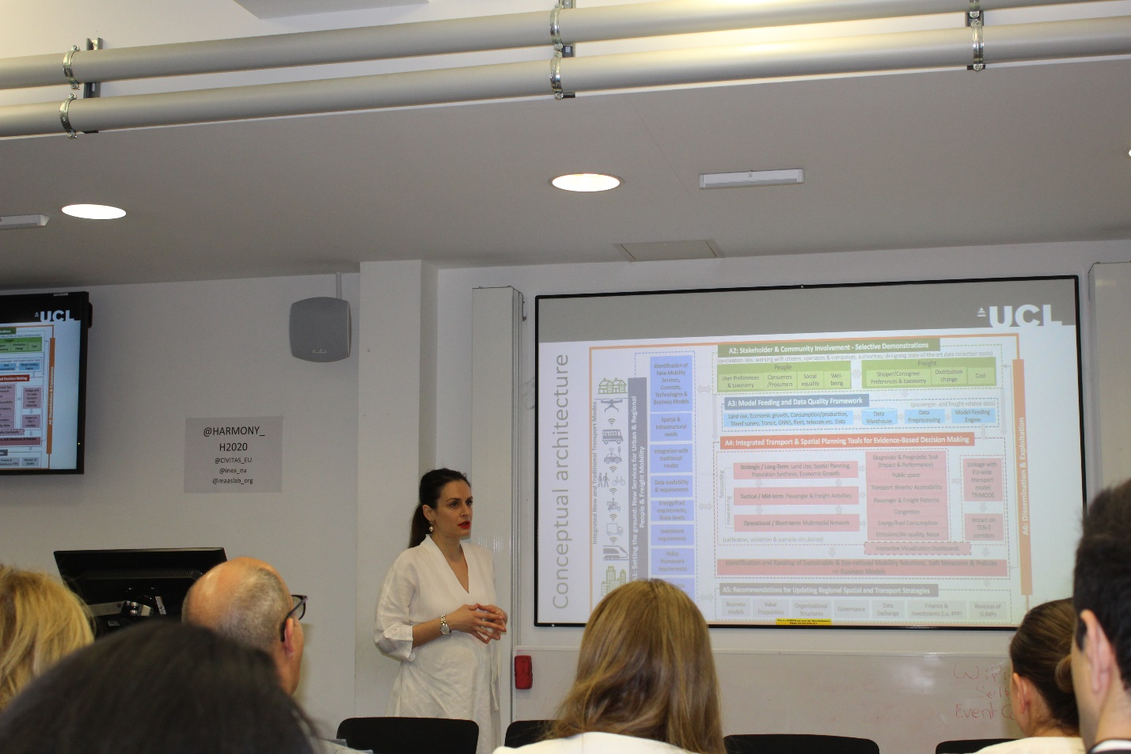
The coordinator prof. Maria Kamargianni at the HARMONY launch event, London, 7th June 2019
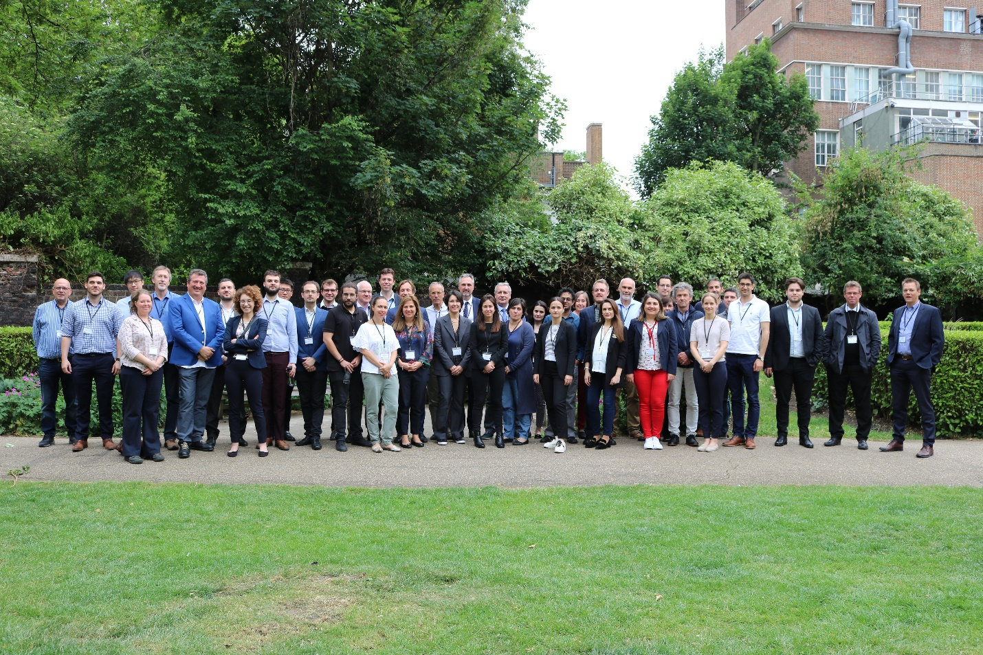

The HARMONY consortium at the Kick-off meeting in London, 5th June 2019

